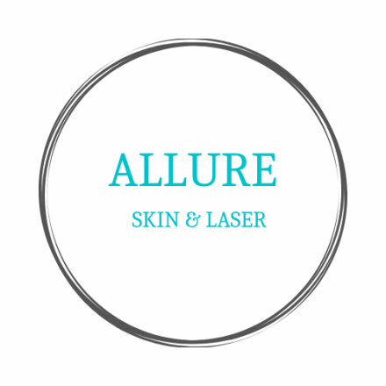

Informed Consent

I understand that I will receive medical cosmetic treatments from Allure Skin and Laser. I also understand that clinical results may vary with different skin types, hair color and area location on the body. The various treatments Allure Skin and Laser provides include Laser hair reduction, skin rejuvenation, intense pulse light treatments, collagen synthesis, skin tightening, fractional laser treatments, Botox®, Dysport®, Juvederm®/Restylane® fillers , chemical peels, and facials.
Patient Initials: _____

I agree to make the office aware if I will be using third party financing such as Care Credit® at the start of my consultation, and, prior to purchasing/requesting services. Financing is not available for product purchase unless part of a treatment package.
Patient Initials: _____

Furthermore, I understand the Refund Policy allows exchanges on service (excluding products) of equal or lesser value and/or may be transferable.
Patient Initials: _____

I further understand that Allure Skin and Laser quoted a price for treatment based upon the amount of treatments purchased and further understand that when treatments are purchased in a series package the rates quoted are discounted from each treatments original retail price. I understand that the treatments Allure Skin and Laser provides can require more than the original amount estimated for treatment at retail value for single treatments.
Patient Initials: _____

I am fully aware that my condition is solely of cosmetic concern and that the decision to proceed is based on my expressed desire to do so.
Patient Initials: _____

I authorize Allure Skin and Laser, its providers and staff members to take before and after pictures of the procedure(s) that will be performed on me. I understand that these pictures will only be used to determine the optimum outcome of my service and/or treatment. Photos will not be used for social media unless a separate consent form is signed.
Patient Initials: _____

I am aware that Allure Skin and Laser requires 24 hours notice of cancellation or of a need to reschedule and that it is my responsibility to provide notice. I agree to pay a cancellation fee of $50.00, if I fail to give the required 24-hour notice. If is choose to prepay my treatment sessions, I understand that I may forfeit one of my future sessions if I do not provide Allure Skin and Laser proper notice (24 hours).
Patient Initials: _____

_________________________________________________________________ _____________________________________
Signature of Patient or Legal Guardian Date

