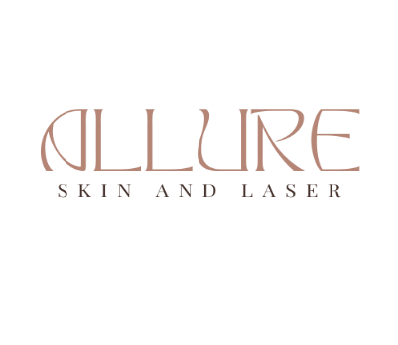
Patient Intake Form
Name: ___________________________________________ ____DOB: ____/____/____ Date: ___/____/____
Phone Number: _______________________________ Email: ________________________________________
Address: ____________________________________ City: ____________________ State: ____ Zip: _________
Emergency Contact: ______________________________ Phone Number: ______________________________
___ I give permission to Allure Skin and Laser to send me occasional email newsletters and promotions.
How did you hear about us? (Please fill in account name or check)
Instagram : ____ Friend/Family: _____________________________________
Google: ____ Facebook : ____ Other (list): _________

Reason for visit: ______________________________________________________________________________
What is your current daily skin care regimen?
AM: ________________________________________ PM: ____________________________________________

Previous Procedures: Which of the following have you had in the past? (Please check all that apply)
___Botox ___ Tattoo Removal
___Jeuveau ___ Laser Hair Removal (Location_________)
___Injectable Fillers (ie Juvederm, Vollure, Voluma etc) ___ Permanent Makeup or Microblading
___ Facials ___ Laser/Skin Resurfacing
___ Microdermabrasion ___ Photofacial/ IPL
___ Chemical Peels ___ Skin Tightening
___ Microneedling ___Waxing or Threading
___ Microneedling with PRP ___ Ultherapy
___ Cellulite Reduction/ Body Contouring
___ Electrolysis
___ Facial Cosmetic Surgery: ________________________________________________

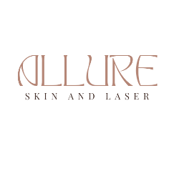
Medical History
Name: ___________________________________________ ____ DOB: ____/____/____
Current Medications: (Including Topical Medications like Allergies and Reaction: (Including Latex, Medications,
Rein-A, Tretinoin, etc) food, if none, write “none” )
____________________________________________ ____________________________________________
____________________________________________ ____________________________________________
____________________________________________ ____________________________________________
Are you pregnant? Y N Are you nursing? Y N Are you planning on becoming pregnant? Y N
Are you currently taking ACCUTANE, or have you taken ACCUTANE in the last 6 months? Y N
Do you use tanning beds? Y N Do you wear sunscreen daily? Y N
Any dental work/cleaning in the last 2 weeks, or an upcoming appointment in the next 2 weeks? Y N
Personal Medical History: (Please check all that apply)
___ Anemia ___ Copper IUD ___Keloid Scars
___Autoimmune Disease ___Diabetes ___ Lupus
___Bleeding Disorder ___Fibromyalgia ___ Metal Implants
___ Blood Clots ___ Heart Disease ___ Pacemaker
___ Cancer ___ Hepatitis B or C ___ Raynaud’s Disease
___ Cochlear Implant ___ Herpes Simplex ___ Seizures
___ Colitis ___ High Blood Pressure ___ Stroke
___ Cold Sores ___ HIV / AIDS ___ Thyroid Disorder
___ Connective Tissue Disorder ___ Hysterectomy ___ Valley Fever
___ Other: ________________________________________________________________________________________
Personal Skin History: (Please check all that apply)
___Undiagnosed Skin Lesions ___ Psoriasis ___ Actinic Keratosis
___ Melasma/ “Pregnancy Mask” ___ Shingles ___ Eczema
___ Pigment Disorder (ie Vitiligo)
___ Skin Cancer (Melanoma, Basal Cell Carcinoma, Squamos Cell Carcinoma)
Previous Surgeries: ________________________________________________________________________________

Print Name Signature Date

